MOTOR VEHICLES (THIRD PARTY INSURANCE) ORDINANCE, 1945 (NIGERIA)

Certificate of Insurance
Certificate No: FCW180682026 Policy No: FCS/{{isData}}/18222
{{VEHICLE_MAKE}} - {{MODEL}}
- Index mark and Registration Number of vehicle {{PLATE_NUMBER}}
- Name of Policy Holder {{OWNER_NAME}}
- Effective date of the commencement of insurance for the
- Purposes of the Ordinance(s) {{REG_DATE}}
- Date of expiry of insurance {{EXPIRY_DATE}}
- Persons or classes of persons entitled to drive*
    - The Policy Holder.
    - Any person who is driving on the Policy holder’s order or with his permission.
Provided that the person driving is permitted in accordance with the licensing or other laws or regulations to drive the Motor Vehicle or has been so permitted and is not disqualified by order of a Court of Law or by Reason of any enactment or regulation in that behalf from driving such Motor Vehicle.
- Limitations as to use {{CATEGORY}} (FOR {{CATEGORY}} USE ONLY)
Use in connection with the Policy holders business; whilst the vehicle is being so used the Carriage of passengers (other than for hire or reward) is permitted.
Use for social domestic and pleasure purposes.
The Policy does not cover -
  - Use for hire or reward or for racing, pace-making, reliability trial or speed-testing.
  - Use whilst drawing a trailer except the towing of any one disabled mechanically Propelled vehicle.

THIRD PARTY ONLY

*Limitations rendered inoperative by the provisions of the Motor Vehicles (Third Party Insurance) Ordinance, 1945 (Nigeria), the Motor Vehicles (Third Party Insurance) Act, 1958 (Ghana), the Motor Vehicles (Third Party Insurance) Ordinance, 1948 (Gambia), and the Motor Vehicles (Third Party Insurance), 1949 (Sierra Leone) are not to be included under this heading. "Please verify the status of your policy:
By SMS: text policy No.* Plate No to 33125 or visit www.askniid.org.
Remember: if this policy is not on NIID, it could be fake and you may be embarrassed by Law Enforcement Agents.
I/WE HEREBY CERTIFY that the policy to which this certificate relates is issued in accordance with the provisions of the Motor
Vehicles (Third Party Insurance) Ordinance, 1945 (Nigeria), the Motor Vehicles (ThirdParty Insurance) Act, 1958 (Ghana), the Motor
Vehicles (Third Party Insurance) Ordinance, 1948 (Gambia),and the Motor Vehicles (Third Party Insurance) Ordinance, 1949 (Sierra Leone)

NICON INSURANCE LTD (Approved insurer)
{{CATEGORY}} Motor
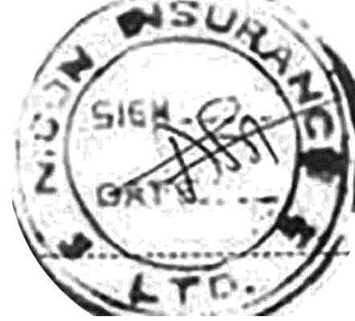
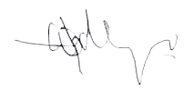
{{isPrice}}
Managing director
Examined

